Name:V.Rachana
AI ASSISTANT
2303a52335 B-44
Lab-6
Task 1: Student Performance Evaluation System
Scenario
You are building a simple academic management module for a university system where student performance needs to be evaluated automatically.
Task Description
Create the skeleton of a Python class named Student with the attributes:
• name
• roll_number
• marks
Write only the class definition and attribute initialization. Then, using GitHub Copilot, prompt the tool to complete:
• A method to display student details
• A method that checks whether the student’s marks are above the class average and returns an appropriate message
Use comments or partial method names to guide Copilot for code completion.
Expected Outcome
• A completed Student class with Copilot-generated methods
• Proper use of:
o self attributes
o Conditional statements (if-else)
• Sample output showing student details and performance status
Prompt Given to Copilot
create method to display student details and method to check if marks are above class average using if else
Explanation
- Created a class with attributes using __init__
- Used self to access object data
- Used if-else to compare marks with class average
- Methods print and return performance result
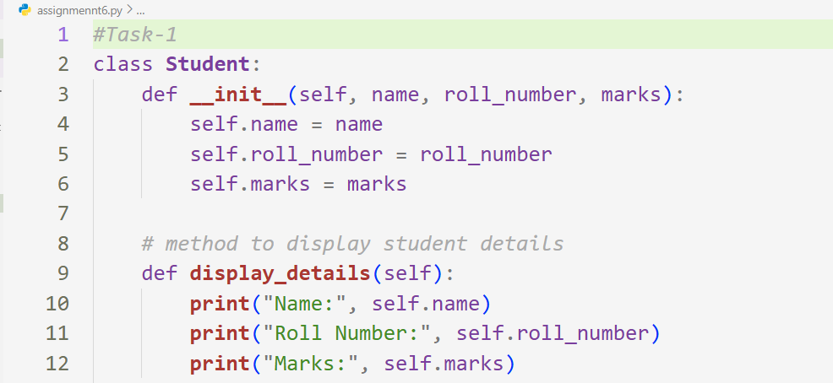
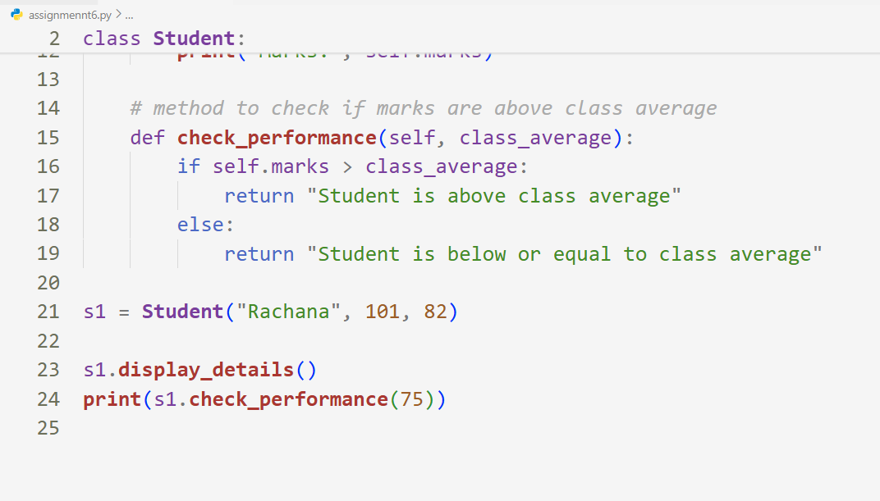
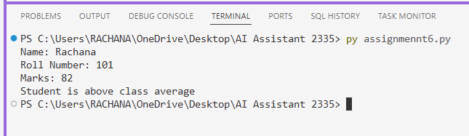

Task 2: Data Processing in a Monitoring System
Prompt Given to Copilot
identify even numbers using modulus operator, calculate square and print formatted output
Explanation
- Used for loop to iterate list
- Used modulus % to detect even numbers
- Calculated square using exponent operator
- Printed formatted output
Scenario
You are working on a basic data monitoring script where sensor readings are collected as numbers. Only even readings need further processing.
Task Description
Write the initial part of a for loop to iterate over a list of integers representing sensor readings.
Add a comment prompt instructing GitHub Copilot to:
• Identify even numbers
• Calculate their square
• Print the result in a readable format
Allow Copilot to complete the remaining loop logic.
Expected Outcome
• A complete for loop generated by Copilot
• Use of:
o Modulus operator to identify even numbers
o Conditional statements
• Correct and formatted output for valid inputs
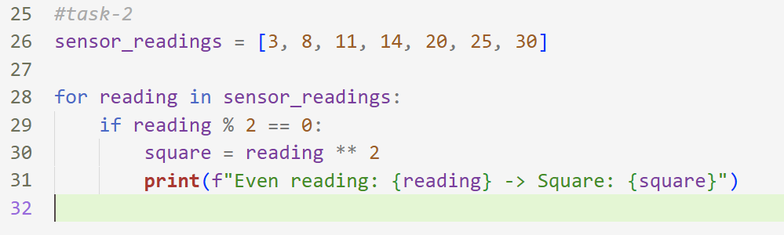
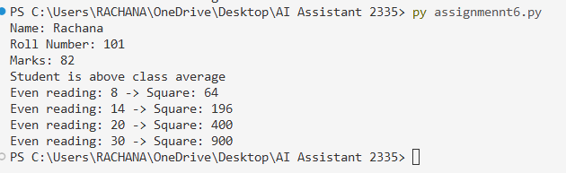

Task 3: Banking Transaction Simulation
Prompt Given to Copilot
generate deposit and withdraw methods using if else and prevent withdrawal if insufficient balance
Explanation
- Class created with account holder and balance
- Deposit adds to balance
- Withdraw checks condition before deducting
- Prevents invalid transactions
Scenario
You are developing a basic banking module that handles deposits and withdrawals for customers.
Task Description
Create the structure of a Python class named BankAccount with attributes:
• account_holder
• balance
Use GitHub Copilot to complete methods for:
• Depositing money
• Withdrawing money
• Preventing withdrawals when the balance is insufficient
Guide Copilot using method names and short comments.
Expected Outcome
• A fully functional BankAccount class
• Copilot-generated methods using:
o if-else conditions
o Class attributes via self
• Proper handling of invalid withdrawal attempts with user-friendly messages
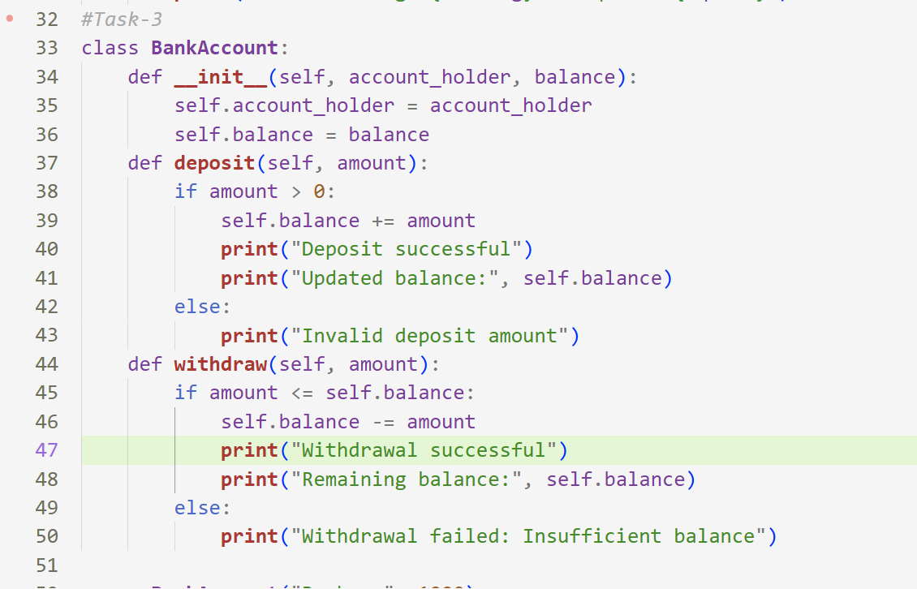
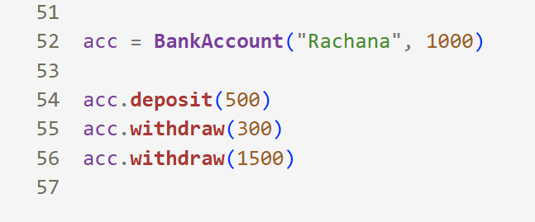
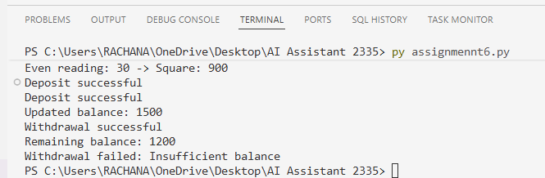
Task 4: Student Scholarship Eligibility Check
Prompt Given to Copilot
write while loop to iterate student list and print names where score > 75
Explanation
- Used list of dictionaries
- Used while loop with index
- Accessed dictionary values by key
- Applied condition check
Scenario
A university wants to identify students eligible for a merit-based scholarship based on their scores.
Task Description
Define a list of dictionaries where each dictionary represents a student
with:
• name
• score
Write the initialization and list structure yourself. Then, prompt GitHub Copilot to generate a while loop that:
• Iterates through the list
• Prints the names of students who scored more than 75
Use comments to guide Copilot’s code completion.
Expected Outcome
• A complete while loop generated by Copilot
• Correct index handling and condition checks
• Cleanly formatted output listing eligible students
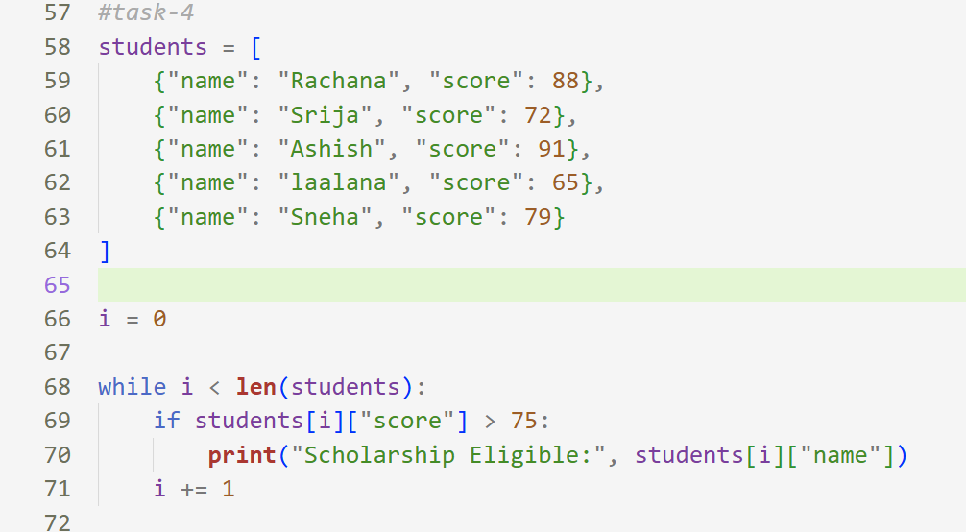
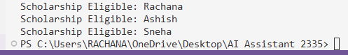
Task 5: Online Shopping Cart Module
Prompt Given to Copilot
create methods to add items, remove items, calculate total using loop and apply discount if total exceeds limit
Explanation
- Used list to store items
- Each item stored as dictionary
- Loop used for total calculation
- Conditional discount applied
- Item removal handled safely
Scenario
You are designing a simplified shopping cart system for an e-commerce
website that supports item management and discount calculation.
Task Description
Begin writing a Python class named ShoppingCart with:
• An empty list to store items (each item may include name, price,
quantity)
Use GitHub Copilot to generate methods that:
• Add items to the cart
• Remove items from the cart
• Calculate the total bill using a loop
• Apply conditional discounts (e.g., discount if total exceeds a
certain amount)
Use meaningful comments and method names to guide Copilot.
Expected Outcome
• A fully implemented ShoppingCart class
• Copilot-generated loops and conditional logic
• Correct handling of item addition, removal, and discount
calculation
• Sample input/output demonstrating cart functionality
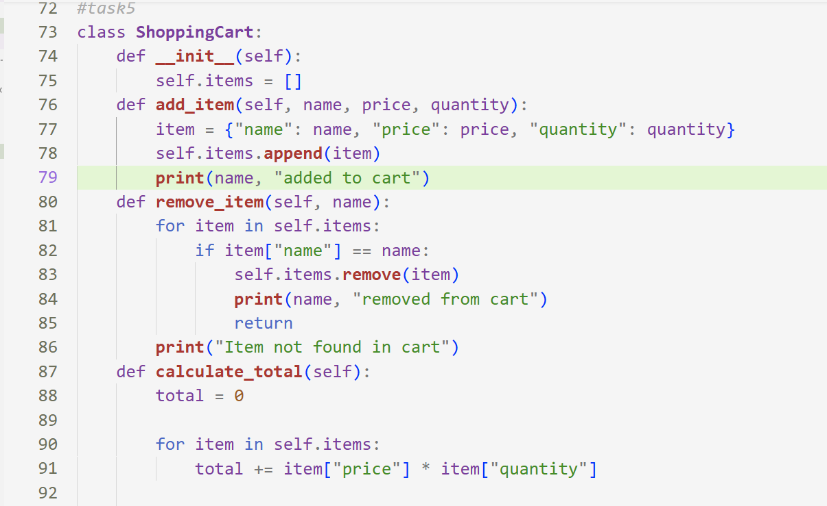
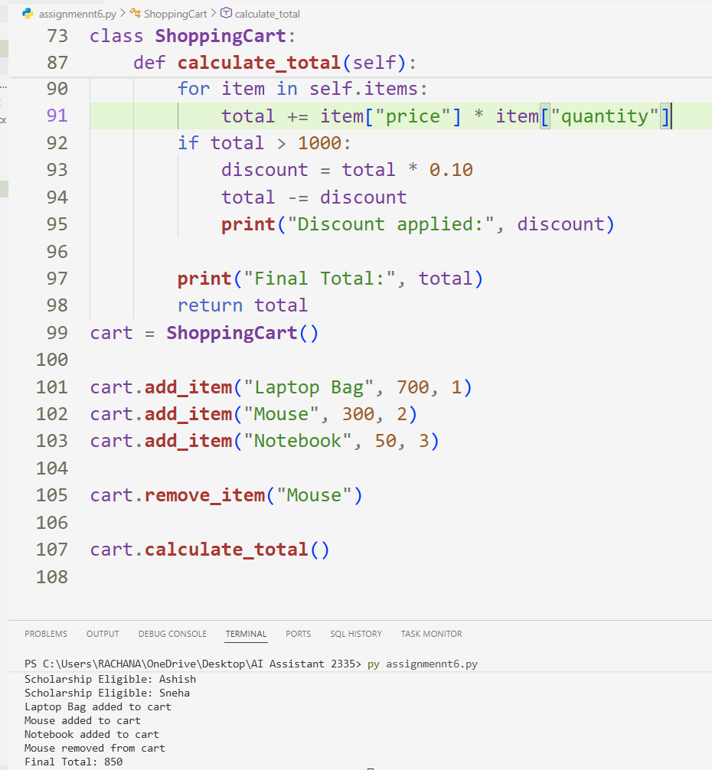

Task 1 — Student Performance Evaluation System
I created a Student class with name, roll number, and marks attributes using a constructor. With Copilot help, I added methods to display details and check performance using if-else conditions.

✅ Task 2 — Data Processing in Monitoring System
I wrote a for loop to iterate through sensor readings and added prompts for Copilot. It generated logic to detect even numbers using modulus and print their squares.

✅ Task 3 — Banking Transaction Simulation
I defined a BankAccount class with account holder and balance fields. Copilot generated deposit and withdraw methods with if-else checks to prevent insufficient balance withdrawal.

✅ Task 4 — Scholarship Eligibility Check
I created a list of student dictionaries with names and scores. Using Copilot guidance, a while loop was generated to print students scoring above 75.

✅ Task 5 — Online Shopping Cart Module
I created a ShoppingCart class with an item list attribute. Copilot generated methods to add/remove items and calculate total with loop and discount condition.

